1405 S. Fern Street #91272 |Arlington, Virginia 22202
Social Security Number: xxx-xx-2924 | Country of Citizenship: USA
Interactive Portfolio: JaclynMcConnell.com
E-mail: jaclyn.mcconnell@zephyr.us
Mobile: 804.405.9623

EXECUTIVE SUMMARY

Knowledge-system Architect;
Decision-support Analyst
To compete in the present, technologically accelerating landscape, organizations must continually innovate. The key to the management of innovation is the life-cycle management of enterprise knowledge. The innovative organization seeks not only to continually "push" value along production lines but also to "pull" essential feedback from the environment into its production and service channels. This push/pull dance of information through an open, feedback system enables an organization to make continuous, incremental improvements aligned to emerging needs.

My mission is to empower the autonomy of individuals, organizations, and communities through the continuous curation of actionable business knowledge.

The principal skill that I offer is the ability to orient and design strategic initiatives within the holistic vision of enterprise service-channel management.

SUMMARY OF PROFESSIONAL QUALIFICATIONS

- Applications-oriented technology researcher with a solid background of experience and discipline
- Highly analytical, discerning, decisive, and rational “systems” thinker
- Strong critical-thinking, problem-solving, and organizational skills
- Superb written communication and visual-design skills
- Rapidly absorbs and networks complex, theoretical material into actionable frameworks
- Adept at evaluating and developing strategic plans that actualize project/business objectives
- Maintains high standards for performance and quality
- Committed to personal development, effective communication, and values-driven leadership
- Nurtures productive internal relationships and business partnerships

EMPLOYMENT HISTORY:

May 2020 – Present: Information Systems Analyst II
GEICO | Maryland, USA

- Co-facilitates the creative destruction of bureaucratic entropy through Agile ITSM implementation
- Leads the continuous development and improvement of our end-user self-service channels
- Supports the maturation of technician-facing knowledge infrastructure across teams
- Models workflows, entity relationships, and system requirements
- Though business-process engineering, provides infrastructure and automation to the life-cycle management of user requirements, knowledge artefacts, and business capabilities
- Leverages classical statistical methods and business intelligence tools to transform data into actionable insights
- Formalizes the practice of Agile methodology to continuously progress initiatives
- Coaches and cheers the leadership of colleagues from the side-lines

- BCM Remedy; MS Power BI; SharePoint Designer; Azure DevOps; Excel; SharePoint On-Prem; SharePoint Modern; MS Power Automate; MS Power Apps; MS PowerBI; Aternity
- R; SQL; VBA; yet-unnamed Canvas scripting language

July 2019 – Present: Business Analyst
United Global Group | South Dakota, USA

- Ensures the cohesion and reconciliation of operational and accounting processes with UGG’s business processes via automated workflows, standard naming conventions, and digital checklists
- Catalogues internal business-processes to support ongoing quality control of essential business processes, ISO 9001& 27001 implementation and compliance, and (eventual) satellite-office expansion
- Develops and matures training materials, processes-flow diagrams, checklists and role-interaction dependency diagrams supporting ongoing quality control of core business processes
- Establishes and evolves a data-driven process for continuous identification and vetting of potential opportunities for increasing UGG’s revenue and strengthening its competitive advantage

February 2019 – April 2019: Project Engineer
United Global Group | South Dakota, USA

- Applied IUID philosophy to build a tracking system designed to assure quality throughout the supply-chain and construction processes across sub-contractor interactions: ordering; fabricating; shipping; delivering; receiving; installing; welding; and inspecting
- Collaborated across subject-matter experts to capture and draft formal work procedures and Job Hazards Analyses (JHAs)
- Deconstructed physical engineering drawings into data objects representing steel members, installed parts, and rivets/bolts
- Provided an “active listening” data-capture capability to our on-site team focused on maximizing performance, reducing overall costs, and delivering on-time and in-full, while always assuring site safety

August 2018 – June 2019: Business Analyst
United Global Group - Buildings Division | British Columbia, Canada

- Assisted UGB Strategic Business Director in the development of objectives to help the organization meet its strategic goals
- Assisted UGB Strategic Business Director in creating and implementing a business development strategy to identify new business-development and product-line opportunities
- Coordinated UGB’s data-driven marketing strategy, leveraging various digital-media technologies and web-based marketing initiatives to generate and convert leads, and to attract and maintain builder/dealer network relationships
- Bundled, promoted, assessed, managed and retired product/service lines of purpose-built pre-engineered steel building systems, attractive to niche markets

August 2015 – July 2018: Research Associate
United Global Group | Virginia, USA

- Contributed to the formalization of standardized data-governance and enterprise information-management practices within the US Defense industry
- Provided technical edits, content re-writes, and technical writing for white papers, and RFI’s, RFP’s and final deliverables supporting effective and strategic communication of concepts, solutions, and outcomes for government clients
- Conducted research to critically determine both the scope and the underlying needs driving formal requirements, and developed strategic and persuasive content aligned to these needs
- Built and maintained authoritative-content repository representing UGG’s capabilities, services, experience and partners, and published this information to our organization
- Led an initiative to establish initial phase of a digital-media capability for sensing and responding to emerging customer “need”
- Demonstrated the value of social-media analytics as a customer-oriented feedback channel enabling the transformation of existing business-development and production channels into adaptive sensing loops

May 2005 – August 2015: Independent Consultant/Student
Executive Assistant, Bookkeeping, Record-systems Organization

- Provided routine office-administration support to various small business and executives
- Organized and made accessible content vital to operations
- Instituted system changes to better support small-business owners in their practices of information management
- Utilized a range of software tools to collect and structure data elements

KEY PROJECTS:

February 2019 – April 2019: Project Engineer
Long-base Neutrino Facility, Structural Rehabilitation – Phase I

Designed and implemented data-collection processes and RDBMS database prototype:
- to map an end-to-end story of work accomplished and in-progress
- to support the tracking of daily on-site activities against the work schedule
- to inform daily identification and mitigation of job and safety hazards
- to capture and display emerging information regarding work in-progress or safety hazards
- to track the allocation of resources (manpower, equipment, time, etc.) across project phases, steps, tasks, and activities
- to generate unique data insights informing present and future performance, cost, and schedule optimization

February 2017 – April 2017: Data Analyst
VCU – DriveFactor

- Applied business understanding to design, propose, and demonstrate a data analysis initiative that creates value to DriveFactor and their clients (insurance companies)
- Used a combination of open-source, DoT-provided, and client-supplied data sources to uncover insights regarding the relationship of vehicle collision-avoidance systems and the number and severity of collisions per year/make/model
- Wrote SQL query to extract vehicle year/make/model from stored VIN data

September 2016 – November2016: Data Analyst
VCU – CarMax

- Wrote and demonstrated a Python-based web-scraper to extract criteria-driven used-vehicle search data from Craigslist
- Demonstrated the benefits and drawbacks of pursuing Craigslist as a (big-) data source in response to the question of the number of vehicles matching set criteria currently available for purchase, by region
- Conducted a time-series analysis of vehicles purchased in previous years to predict available pool of select used vehicles in upcoming years
- Generated visualizations and dashboards in Excel and Tableau
- Created a “buyers guide” providing strategic insights of vehicle make/model choices having the most value to prospective vehicle buyers
September 2016 – November 2016: Solution Architect
VCU – National Guard Suicide Prevention

- Designed my first RBMS database!
- Used Oracle MySQL to demonstrate a bureau-level unified database concept supporting the timely intervention of resources for national-guard personnel at high risk of suicide
- Developed a white paper to define and promote the concept
- This concept has since been adopted by my current employer as an initiative

February 2016 – April 2016: Data Analyst
Rapid Development and Sustainment Initiative – Phase I

- Provided an “active listening” data-capture capability for our team-led collaboration sessions across community-of-interest stakeholders
- Performed a text-based, categorical analysis of working-group session data to accurately reflect principle stakeholder areas of concern, potential program risks, beneficial actions, and community-voiced prioritizations
- Assisted Senior Operations Researcher in the development of program-action logic models reflecting recommended actions
- Used Tableau to develop data visualizations supporting high-level communication of risk/benefit, cost/benefit, and DOTMLFP analysis results

REFERENCES:

Name | Mr. Larry Paige | Mr. Jerome Dixon | Mr. Jay Phinizy | Mr. Roy Gunther
Company | United Global Group, Inc. | Virginia Commonwealth University | Virginia Commonwealth University | Kiewit/Alberici, JV
Position | CEO | Student (PhD) | Data Analyst | Client-side Project Lead
Relationship | Direct Supervisor | Colleague | Colleague | Colleague
E-mail | Larry.Paige@UnitedGlobalGrp.com | Jerome.Dixon90@Gmail.Com | JPhinizy@VCU.EDU | roygunther@yahoo.com

EDUCATION:

2017 – Virginia Commonwealth University, Master of Decision Analytics (1 Year, FT studies, GPA 4.0)

2015 – University of Richmond, Bachelor’s Liberal Arts: Independent Studies, Summa Cum Laude

2009 – Thomas Nelson Community College, Associate Degree: Science, Dean’s List

TECHNICAL SKILLS:

The following graphics were generated in R to visualize my present skill set within two contexts: first, by the level of opportunity I have been afforded and/or have devoted to the development of skill sets through work and personal projects (Figure 1); and second, by the level of motivation I have for further developing a given skill-set (Figure 2). Together, these graphics present my past, present, and projected technical-skills development.

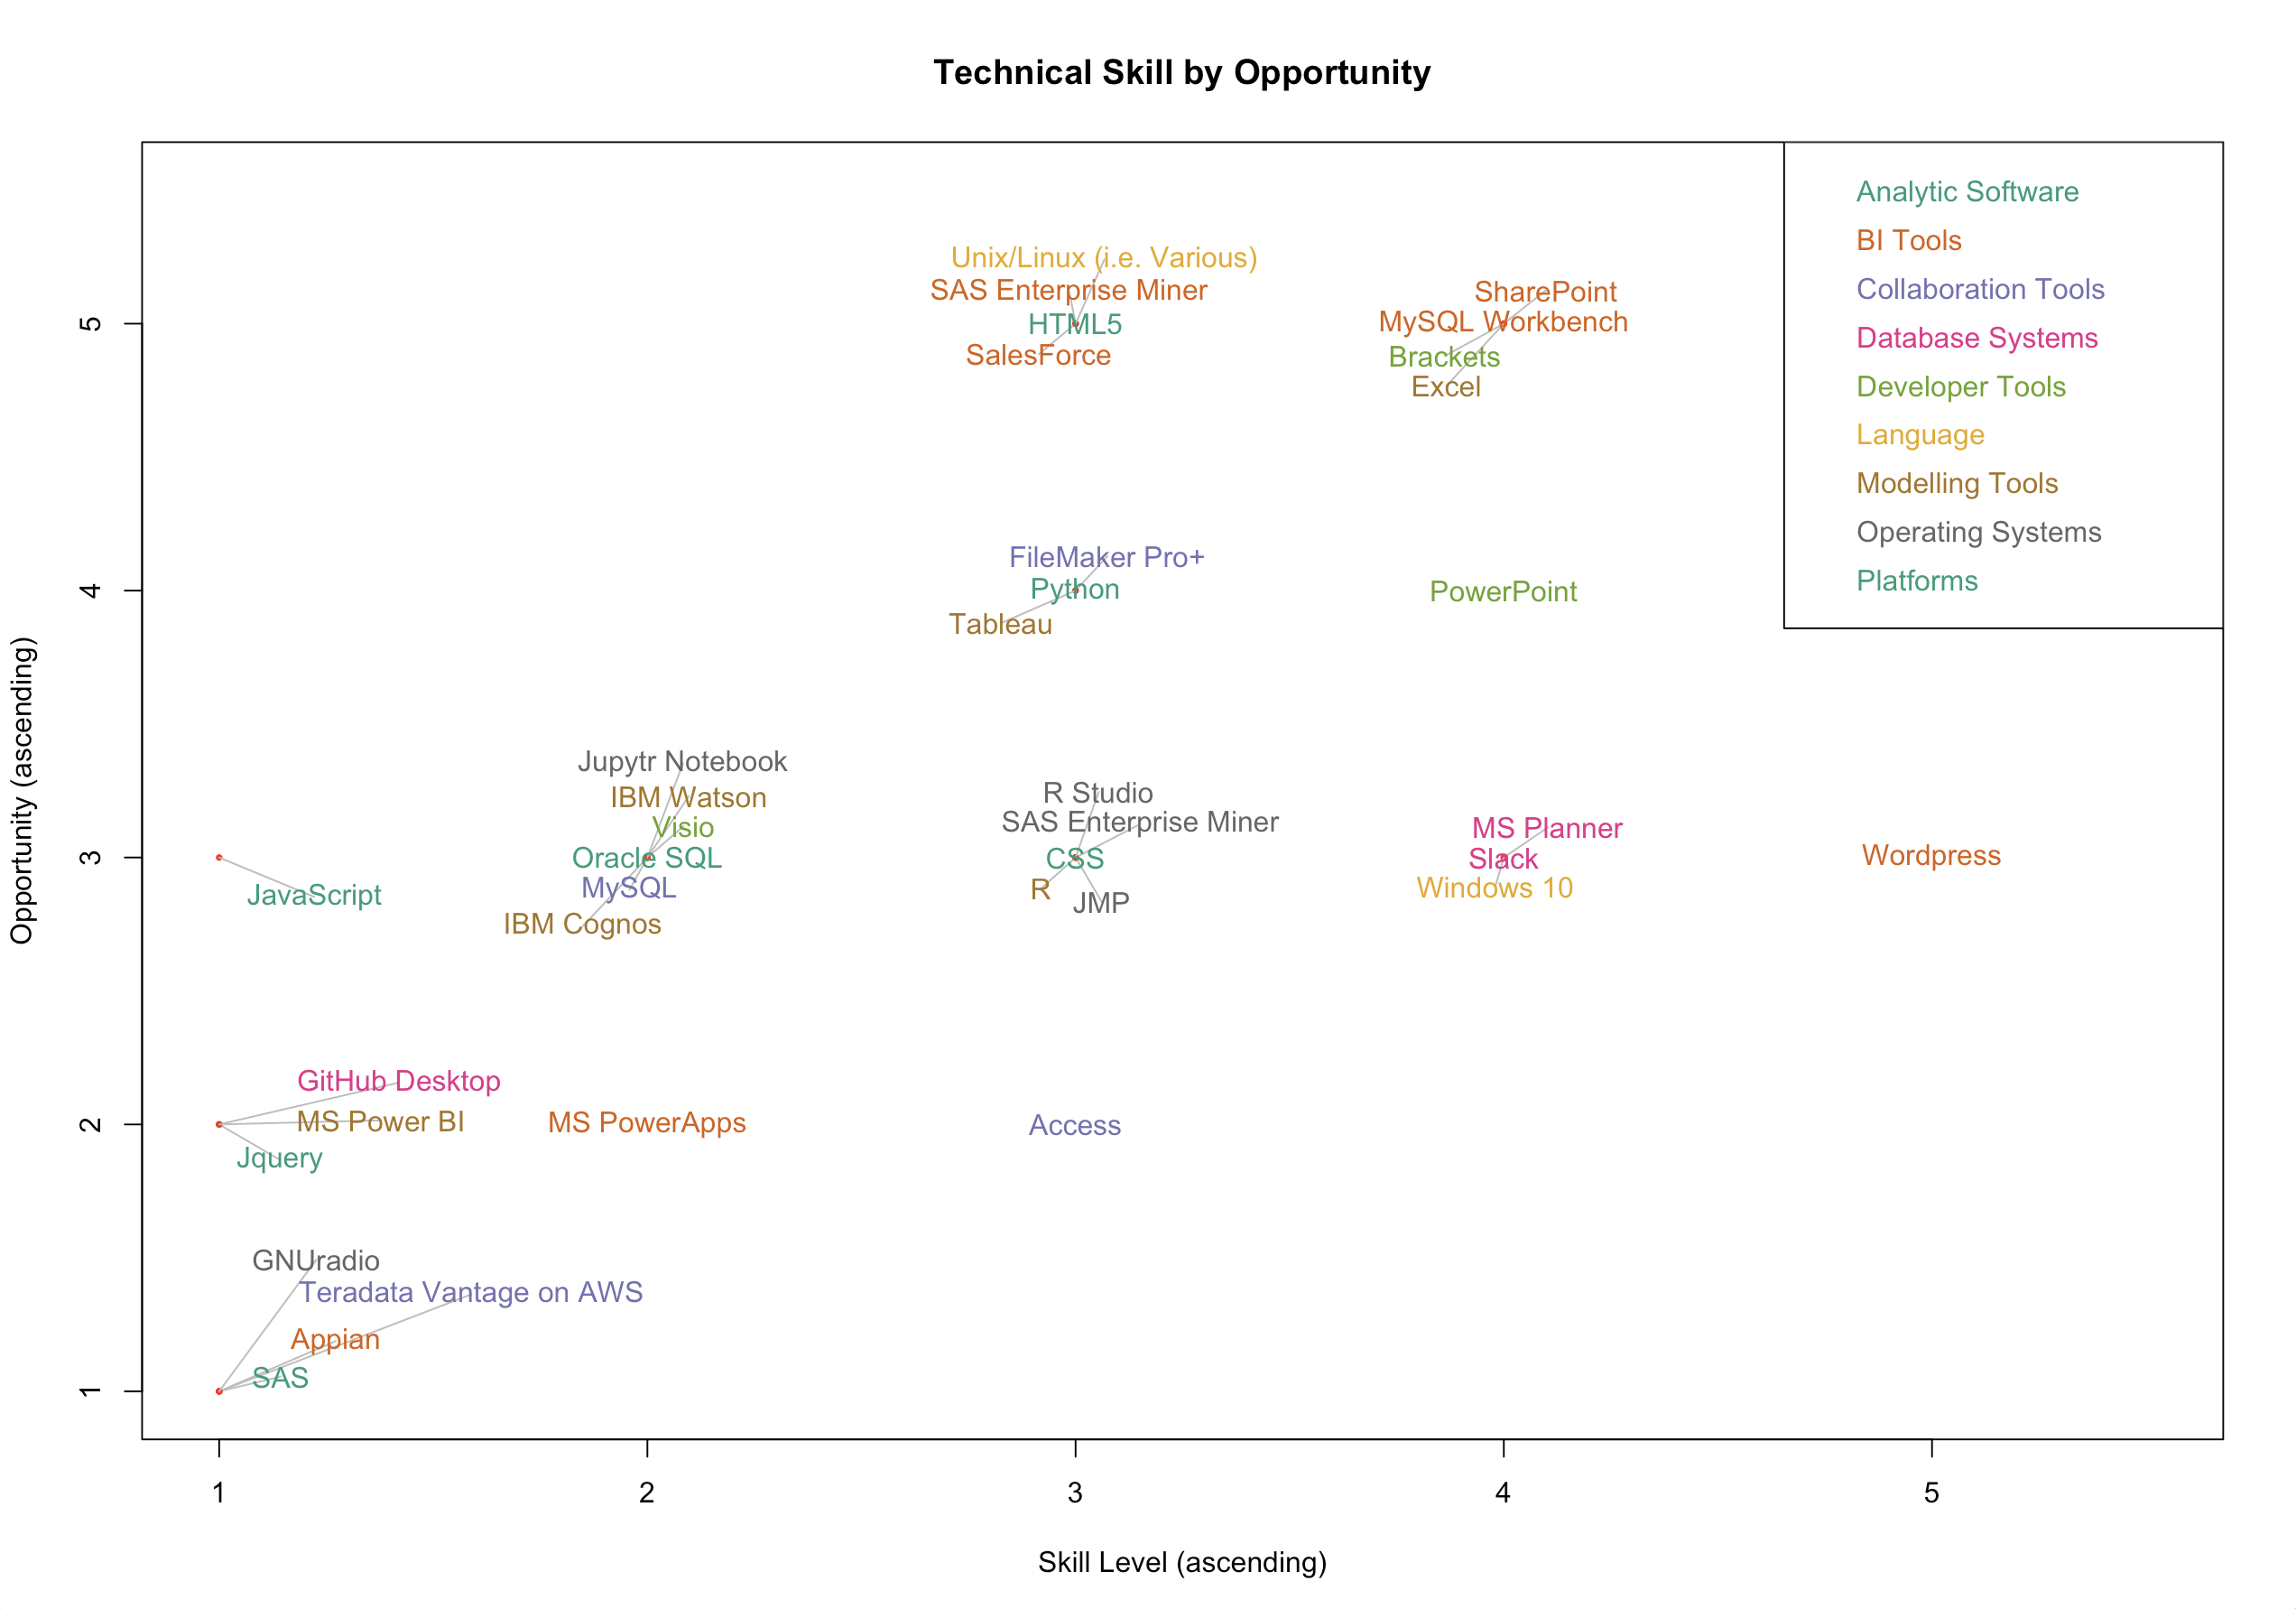
Figure 1

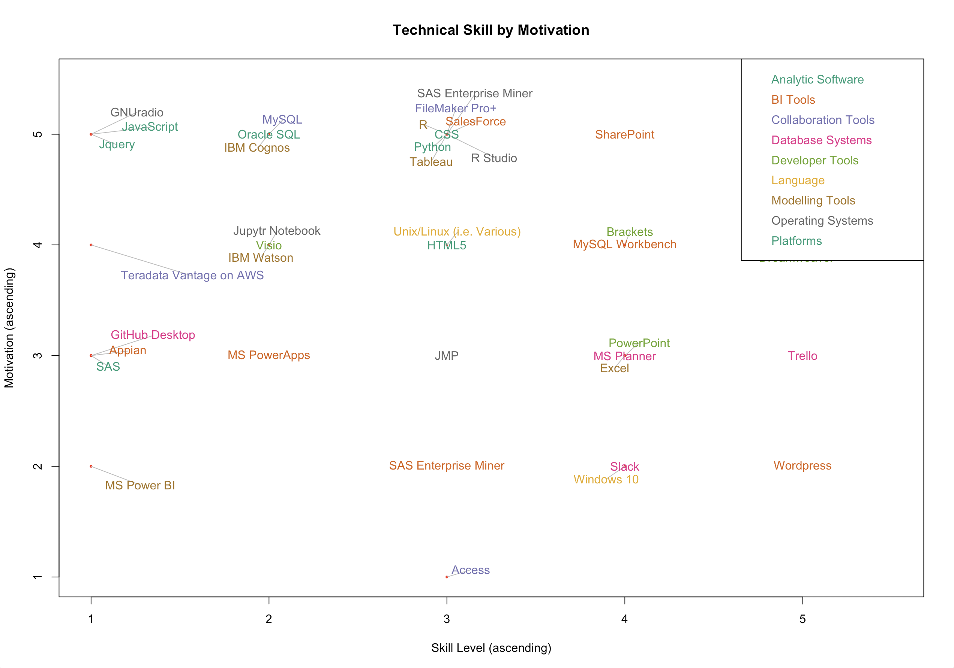
Figure 2

